CPE301 – SPRING 2019

Design Assignment 2, Part A

Student Name: James Skelly

Student #: 2000945485

Student Email: skellj1@unlv.nevada.edu

Primary Github address: https://github.com/skellj1/submission_da

Directory: skellj1/submission_da

Submit the following for all Labs:

1. In the document, for each task submit the modified or included code (only) with highlights and justifications of the modifications. Also, include the comments.
2. Use the previously create a Github repository with a random name (no CPE/301, Lastname, Firstname). Place all labs under the root folder ESD301/DA, sub-folder named LABXX, with one document and one video link file for each lab, place modified asm/c files named as LabXX-TYY.asm/c.
3. If multiple asm/c files or other libraries are used, create a folder LabXX-TYY and place these files inside the folder.
4. The folder should have a) Word document (see template), b) source code file(s) and other include files, c) text file with youtube video links (see template).
5. **COMPONENTS LIST AND CONNECTION BLOCK DIAGRAM w/ PINS**

* Components used for this assignment include Atmel Studio 7, MultiFunction Shield for microcontroller, X-plained Mini Microcontroller board with ATmega328p chip on board, and mEDBG programmer/debugger. Youtube was used to post video, my iPhone was used to record video, and the Tektronix TDS 2014 Oscilloscope was used to measure output waveforms with a 10:1 compensated oscilloscope probe.

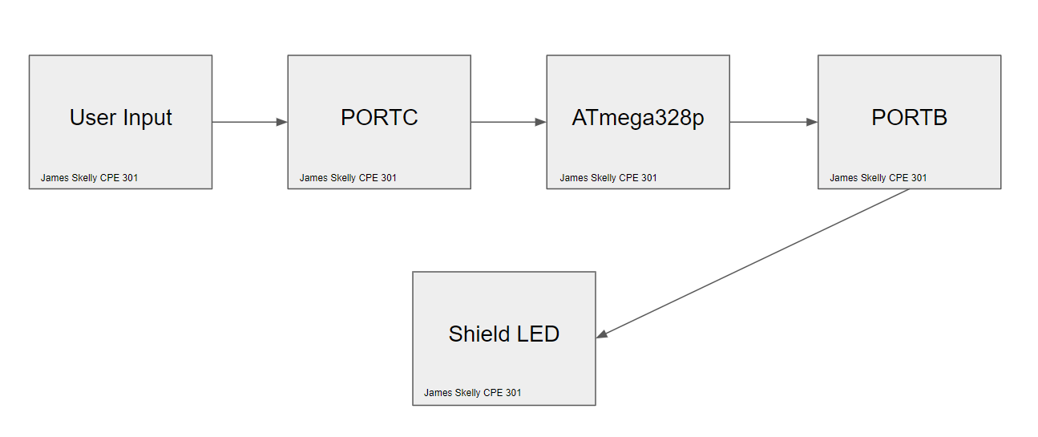

1. **INITIAL/MODIFIED/DEVELOPED CODE OF TASK 1/A**

**Task 1 C Code**

/* DA2A_Task_1_C.c

* Created: 3/1/2019 3:15:00 PM

* Author : James Skelly */

// Design Assignment 2A:

// The goal of the assignment is use GPIO and delays:

// 1. Design a delay subroutine to generate a waveform on PORTB.2 with 60% DC and 0.725

// sec period.

#define *F_CPU* 16000000UL // Set frequency of CPU to 16 MHz for delay function

#include <avr/io.h> // Including AVR and Delay header libraries

#include <util/delay.h>

int main(void)

{

DDRB = 0x04; // Set data direction register bit 2 as an output

while(1)

PORTB = (1 << PORTB2); // Shift a 1 into PORTB.2

*_delay_ms*(435); // Call for delay of 435 ms (0.725s * 0.6)

PORTB = ~(1 << PORTB2); // Shift a 0 into PORTB.2

*_delay_ms*(290); // Call for delay of 290 ms (0.725s * 0.4)

return 0;

}

**Task 1 Assembly Code**

; DA2A_Task_1.asm

; Created: 3/1/2019 3:05:51 PM

; Author : James Skelly

; Replace with your application code

; Design Assignment 2A:

; The goal of the assignment is use GPIO and delays:

; 1. Design a delay subroutine to generate a waveform on PORTB.2 with 60% DC and 0.725

; sec period.

LDI R19, 0x04 // Load immediate 0x04 into r19

LDI R20, 0x00 // Load immediate 0x00 into R20

OUT DDRB, R19 // Set PORTB.2 to output

main:

OUT PORTB, R19 // Set PORTB.2 high

rcall delay_100ms // Call for a delay of 435 ms

rcall delay_100ms //

rcall delay_100ms //

rcall delay_100ms //

rcall delay_10ms //

rcall delay_10ms //

rcall delay_10ms //

rcall delay_5ms // End of 435 ms delay

OUT PORTB, R20 // Set PORTB.2 low

rcall delay_100ms // Call for a delay of 290 ms

rcall delay_100ms //

rcall delay_10ms //

rcall delay_10ms //

rcall delay_10ms //

rcall delay_10ms //

rcall delay_10ms //

rcall delay_10ms //

rcall delay_10ms //

rcall delay_10ms //

rcall delay_10ms // End of 290 ms delay

rjmp main // Jump back to the top of the loop

**Developed Delay Subroutine for 1ms Delay**

delay_1ms:

push r16 // push r16 to stack

push r18 // push r18 to stack

ldi r16, 255 // load 255 into r16

ldi r18, 6 // load 6 into r18

delay_1b: // label for outer loop

delay_1a: // label for inner loop

nop // no operation, takes 1 cycle

nop //

nop //

nop //

nop //

nop //

nop //

dec r16 // decrement the value in r16

brne delay_1a // if the value in r16 is not 0,

// stay in the loop

dec r18 // decrement the value in r18

brne delay_1b // if the value in r18 is not 0,

// stay in the loop

pop r18 // pop r18 back from the stack

pop r16 // pop r16 back from the stack

ret // return to line below rcall

**The code above was created to generate a subroutine that would last 1 ms. This subroutine was used as the building block for larger delays in assembly throughout this assignment. Calculating the delay generated by this subroutine was conducted by counting the number of instructions per loop and multiplying that number by the time taken to complete one cycle at 16 MHz, or 62.5 nanoseconds. Calculations led to a final generated delay of roughly 1.005ms. Adding more loops, more nop instructions, or subtracting loops and nop instructions only took the value further away from exactly 1ms. This value of 1.005 ms causes minor differences in the output waveforms between assembly and C throughout this design assignment.**

**Note that for task 1 code, logic was flipped in order to see the pulse high for 435 ms, and low for 290 ms. If the logic was kept reversed, the pulses would have looked similar to those in task two, where the pulse of the LED on actually makes the waveform go low.**

1. **DEVELOPED/MODIFIED CODE OF TASK 2/A from TASK 1/A**

**Task 2 C Code**

/* DA2A_Task_2_C.c

* Created: 3/1/2019 3:15:26 PM

* Author : James Skelly */

// 2. Connect a switch to PORTC.2 to poll for an event to turn on the LED

// at PORTB.2 for 1.250 seconds after the event.

#define *F_CPU* 16000000UL // Set frequency of CPU to 16 MHz for delay function

#include <avr/io.h> // Including AVR and Delay header libraries

#include <util/delay.h>

int main (void)

{

DDRB |= (1<<2); // Sets DDRB pin 2 to output mode by performing bitwise

// OR with a 1 shifted two places to the left, and

// and the value previously stored in DDRB. The

// result will be stored in DDRB.

PORTB |= (1<<2); // Sets PORTB pin 2 to high by performing bitwise

// OR with a 1 shifted two places to the left, and

// and the value previously stored in PORTB. The

// result will be stored in PORTB. This will initially

// turn the LED off.

DDRC &= (0 << 2); // Sets DDRC pin 2 to input mode by performing bitwise A

// AND with a 0 shifted two places to the left, and the

// value previously stored in DDRC. The result will

// be stored in DDRC.

PORTC |= (1 << 2); // Sets PORTC pin 2 to high by performing bitwise

// OR with a 1 shifted two places to the left, and

// and the value previously stored in PORTC. The

// result will be stored in PORTC. This enables the

// pull-up resistor.

while (1)

{

if (!(PINC & (1<<PINC2))) // Check PINC1 for a value of 1,

// complemented to check for a // zero instead.

{

PORTB &= ~(1<<2); // Turn on LED by setting PORTB.2 to 0.

*_delay_ms*(1250); // Call for a delay of 1.25 seconds

}

else

PORTB |= (1<<2); // Turn off the LED by setting PORTB.2 to 1.

}

return 0;

}

**Task 2 Assembly Code**

; DA2A_2_ASM.asm

; Created: 3/1/2019 3:14:30 PM

; Author : James Skelly

; 2. Connect a switch to PORTC.2 to poll for an event to turn on the LED

; at PORTB.2 for 1.250 seconds after the event.

.ORG 0

LDI R16, 0x04 ; loads 0x04 into register 16

LDI R17, 0x00 ; loads 0x04 into register 17

OUT DDRB, R16 ; sets data direction register PORTB.2 to output

OUT DDRC, R17 ; sets data direction register PORTC to all inputs

OUT PORTB,R16 ; sets PORTB.2 high

OUT PORTC, R16 ; sets port C, pin 2 high

NOP

MAIN:

IN R18, PINC ; reads input on pin C into register 20

COM R18 ; invert the bits inputted to pin c

ANDI R18, 0x04 ; bitwise AND the value in register 20 with 0x04

CPI R18, 0x04 ; compare the value in r20 with 0x04

BRNE MAIN

LIGHT_ON:

LDI R21, 0xFB ; 11111011 INTO R21

OUT PORTB, R21 ; OUTPUT PORTB.2 LED 4 turns on

rcall delay_1s ; call for delay of 1.25 s

rcall delay_100ms ;

rcall delay_100ms ;

rcall delay_50ms ; end of 1.25 s delay

OUT PORTB, R16 ; turn LED off

RJMP MAIN ; jump back to top of code

1. **SCHEMATICS**

**Task 1 Schematic**

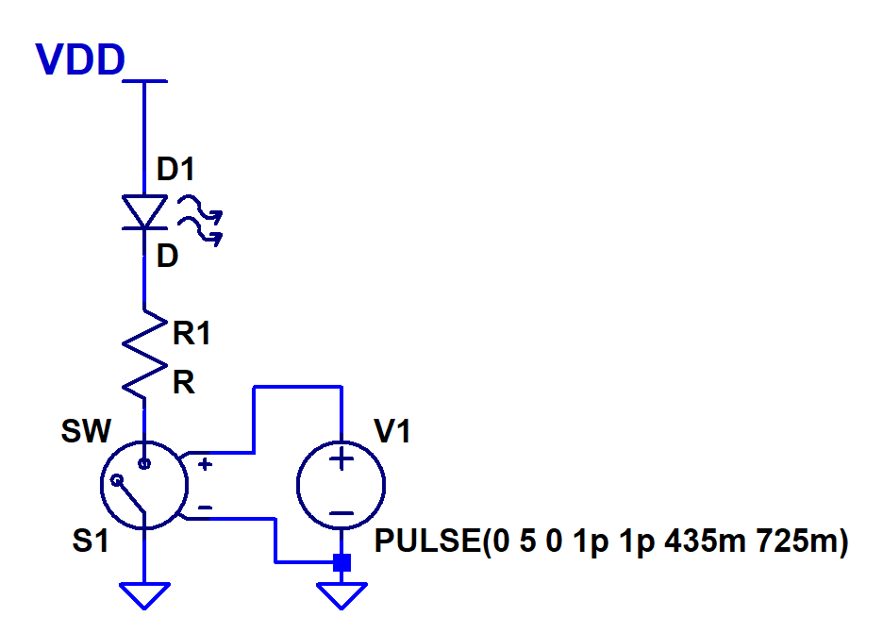

The pulse source models the instructions given to the ATmega to output a 725ms period waveform with a 60% duty cycle.

**Task 2 Schematic**

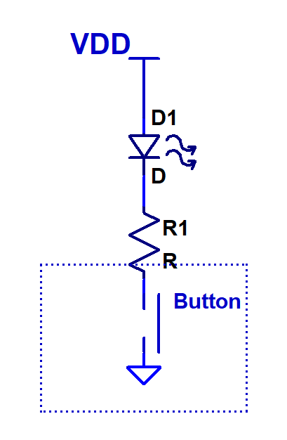

Button gets pressed, connects wire to ground. PB2 is connected to PC2 through the board, and the LED lights up for a time after the button is pressed.

1. **SCREENSHOTS OF EACH TASK OUTPUT (ATMEL STUDIO OUTPUT)**

**Task 1 C**

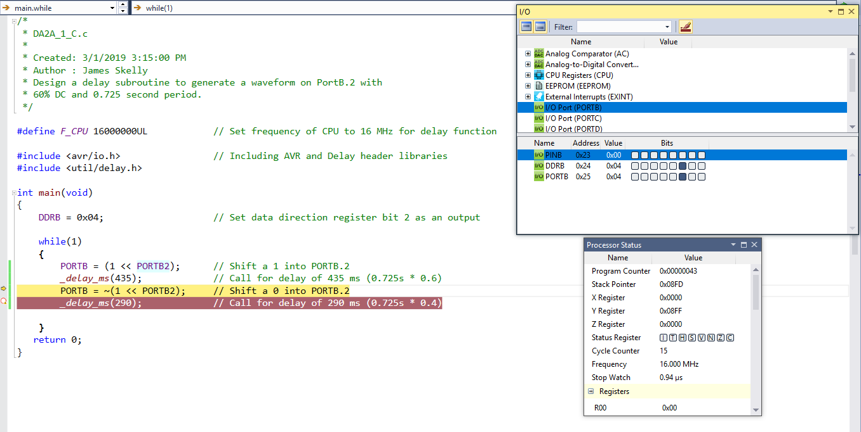

**Task 1 Assembly**

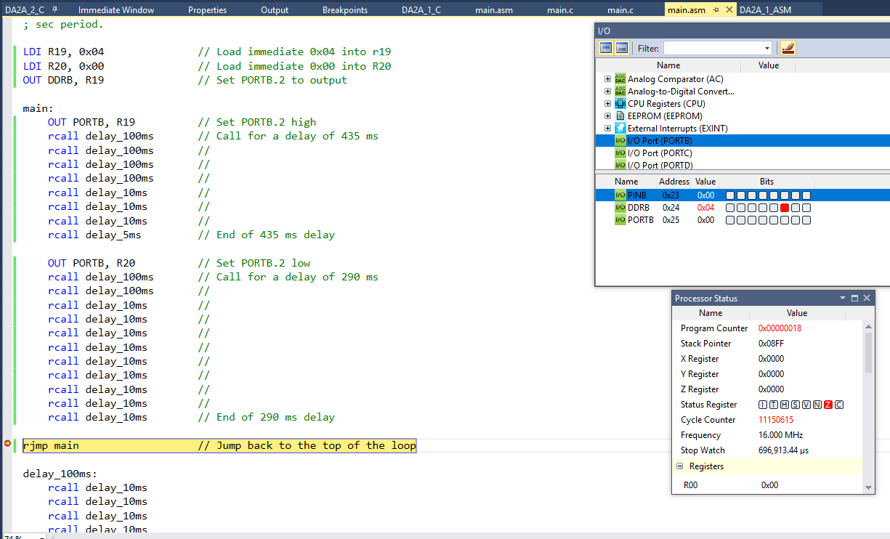

**Here we see the stopwatch measure 696 ms, which is exactly the period of the waveform measured by the oscilloscope.**

**Task 2 C**

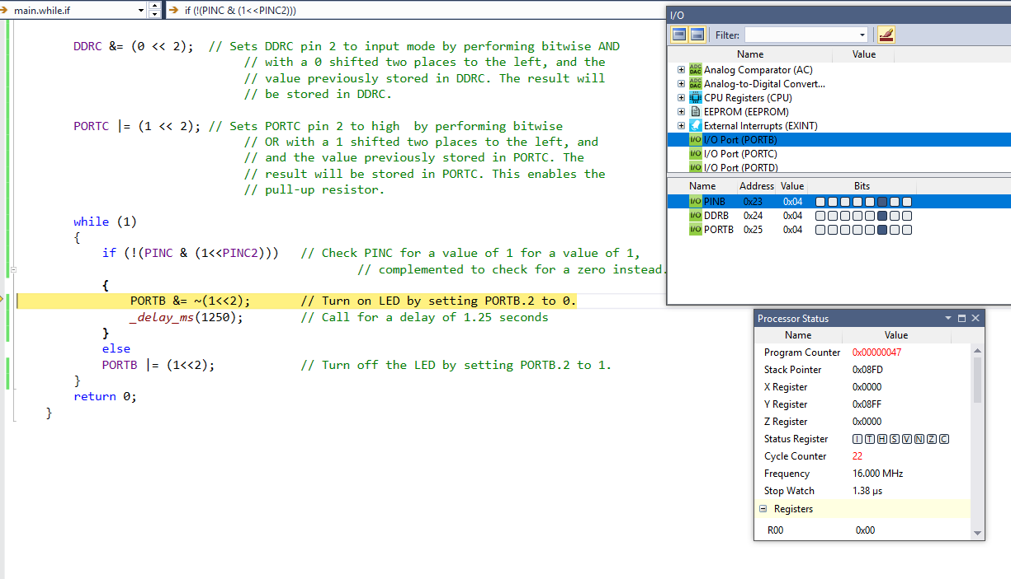

**When programming in C, far less instructions are required to perform tasks, so our stop watch only records a total time of 1.38 microseconds.**

**Task 2 Assembly**

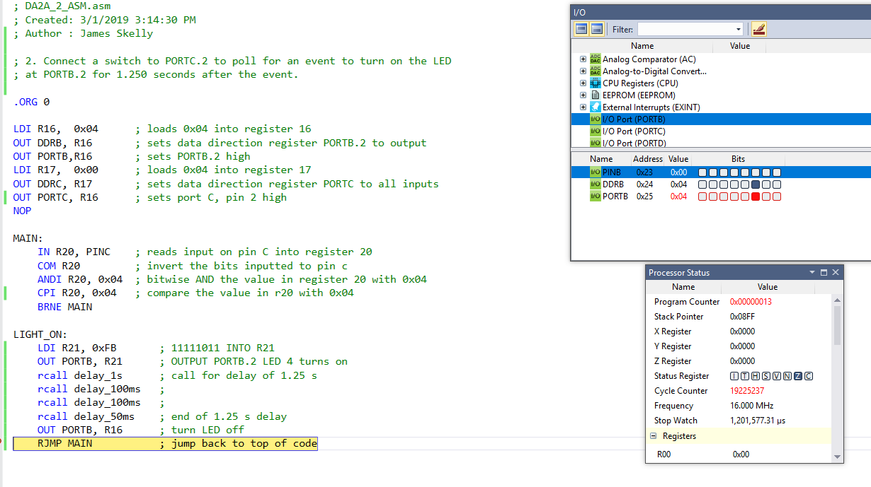

**We see here the stop watch measured 1.201 seconds in simulation. This is very similar to our experimental value.**

1. **SCREENSHOT OF EACH DEMO (BOARD SETUP)**

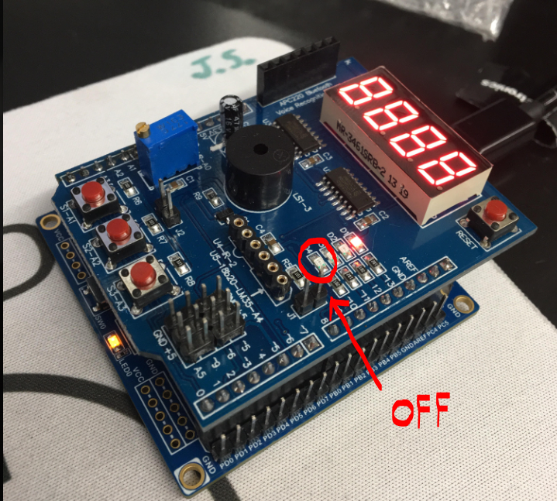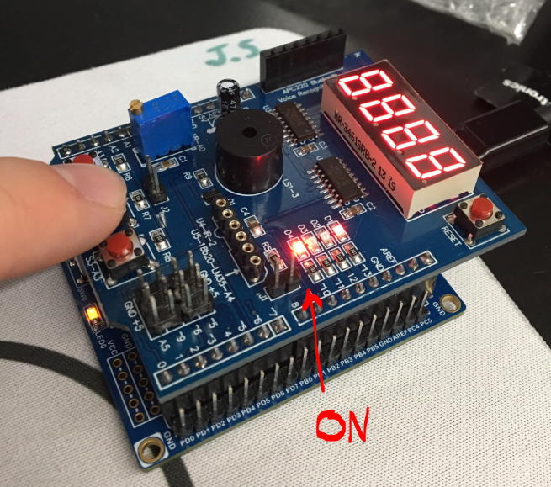

**Task 1: Design a delay subroutine to generate a waveform on PORTB.2 with 60% DC and 0.725 second period.**

**TASK 1 C Code SCOPE OUTPUT**

* **Note that for parts 1 and 2, Assembly and C, the same board setup shown below was used. A 10:1 compensated scope probe was used to probe the signal on PORTB.2 and made visible on the oscilloscope for analysis using cursors.**

**Period of Waveform is 0.724 seconds. Board Setup with PB2 and GND Connected to Probe**

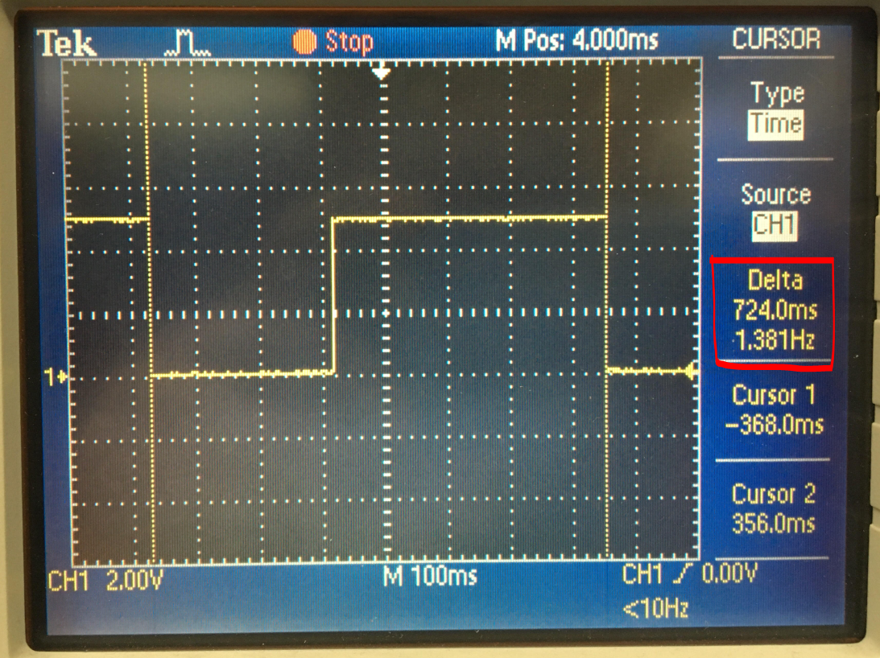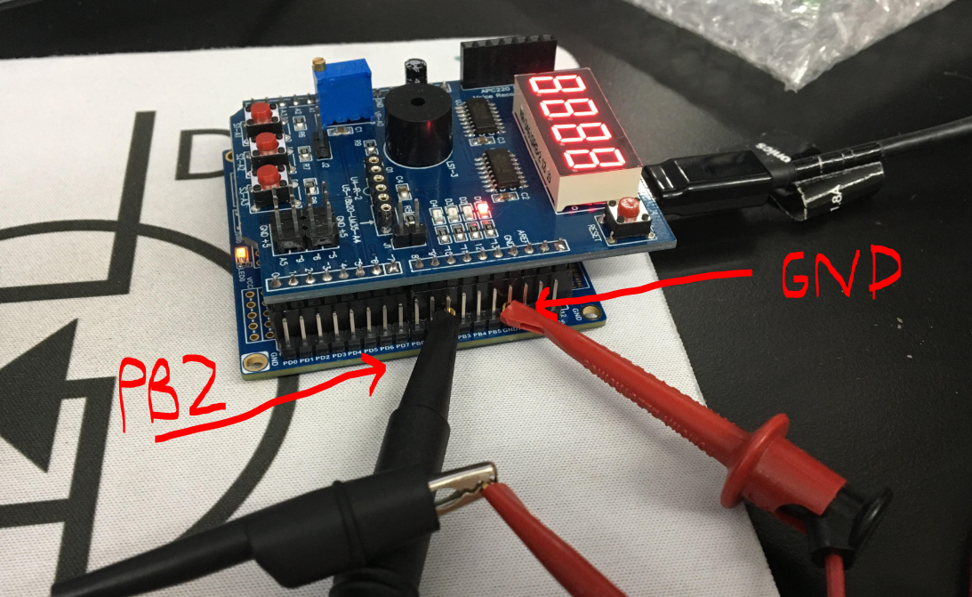

**Time low should be (0.725 s * 0.4 = 290 ms). Time high should be (0.725s * 0.6 = 435 ms)**

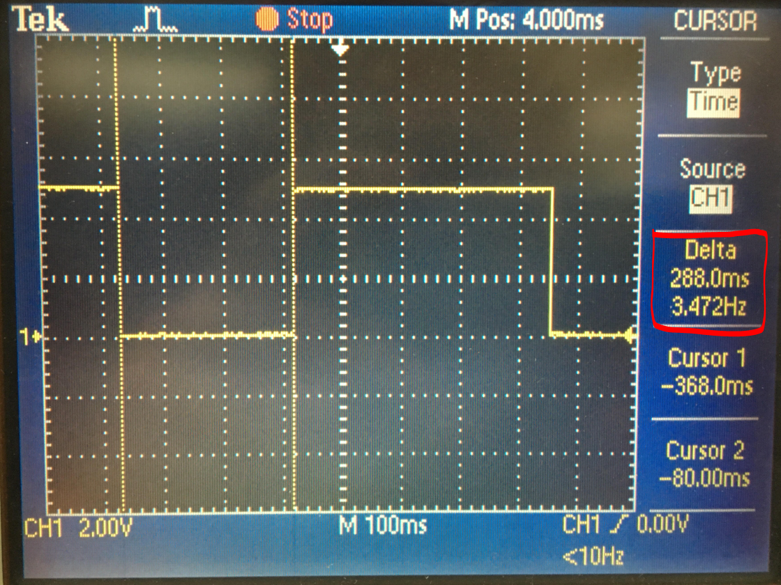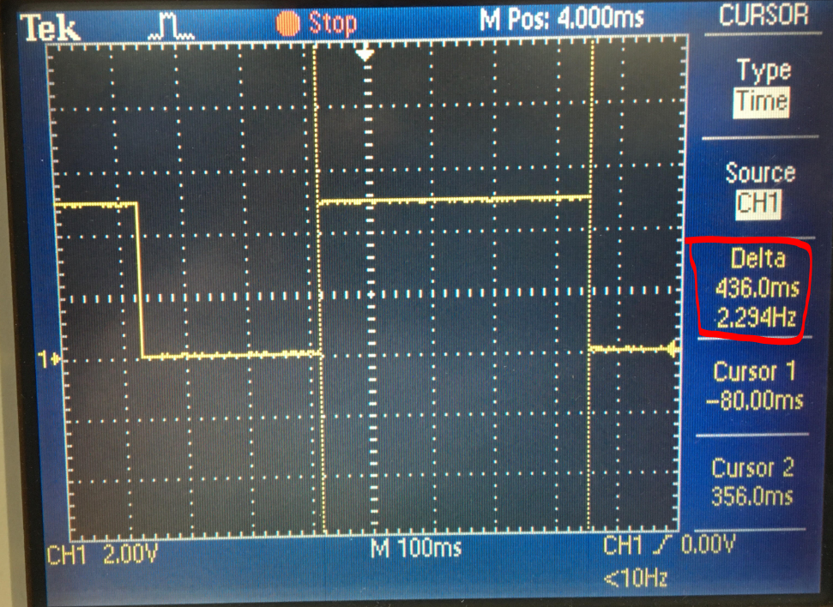

**The C code for task 1 gave very accurate output waveforms, with the time high and the period varying from the expected values by only 1 millisecond, and the time low varying by 2 milliseconds.**

**TASK 1 Assembly Code SCOPE OUTPUT**

* **In the waveforms below, we will see that there are small differences between our calculated or expected values and the actual time high, time low, and period of the signal. That is because in Assembly, without using timers, generating a delay for an exact amount of time is not easy. Had I used the internal timers of the ATmega328p, I could have generated a more accurate signal.**

**Period of Waveform is 0.696 seconds. Board Setup with PB2 and GND Connected to Probe**

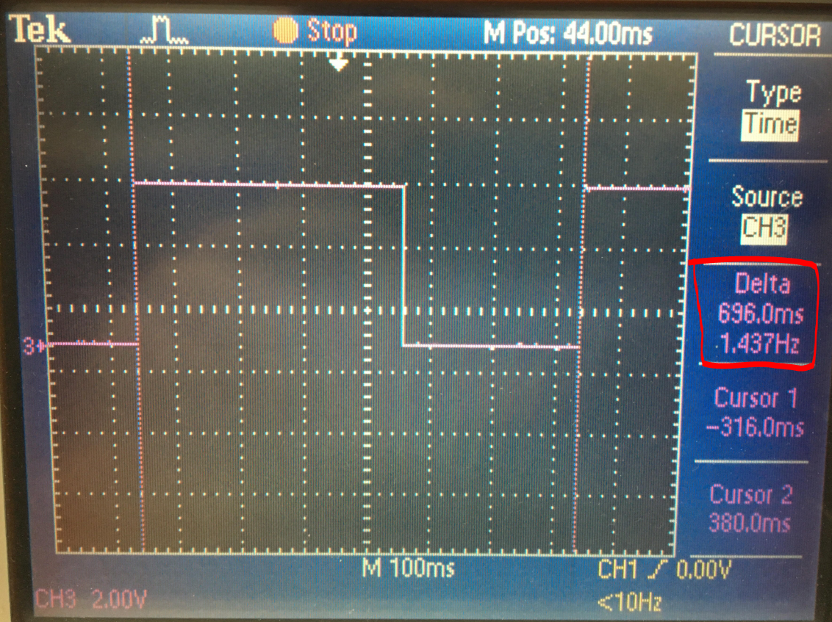

**Time low SHOULD BE (0.725 s * 0.4 = 290 ms). Time high SHOULD BE (0.725s * 0.6 = 435 ms)**

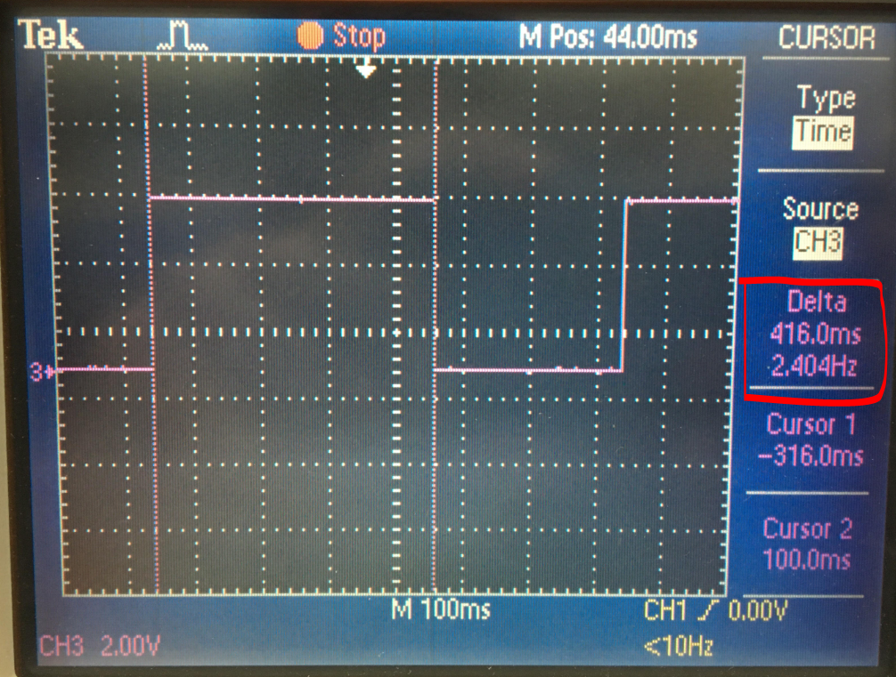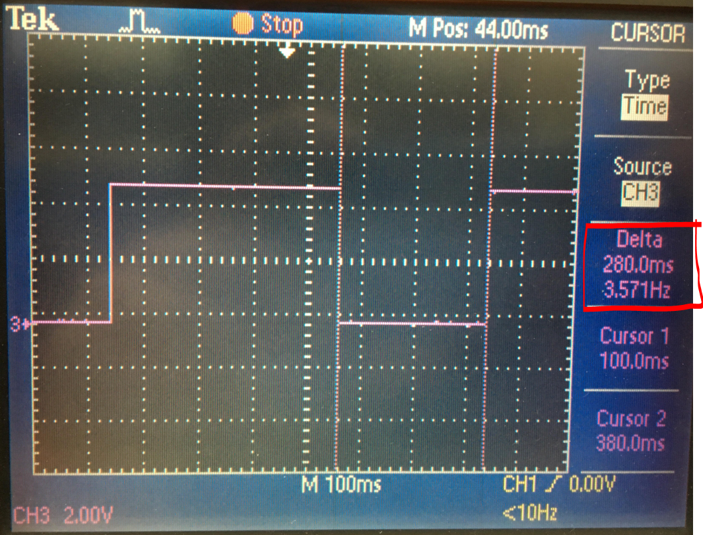

**Calculating an estimate for the time taken to complete my delay_1ms subroutine using a 62.5 ns time per cycle at 16 MHz yielded that my delay_1ms subroutine was taking about 1.005 ms to execute. With millions of cycles running to generate larger delays, this 5 microsecond overshoot is what is causing the variations between my waveforms and my calculations for expected time high, time low, and period.**

**Task 2: Connect a switch to PORTC.2 to poll for an event to turn on the LED at PORTB.2 for 1.250 seconds after the event.**

**TASK 2 C Code SCOPE OUTPUT**

* **The C code for part 2 worked perfectly, outputting a pulse low (reverse logic) to turn on the LED for exactly 1.250 seconds. The scope was adjusted to have a high seconds per division measurement so that the pulse could be captured and measured.**

**Width of Pulse is 1.250 seconds. Board Setup with PB2 and GND Connected to Probe**

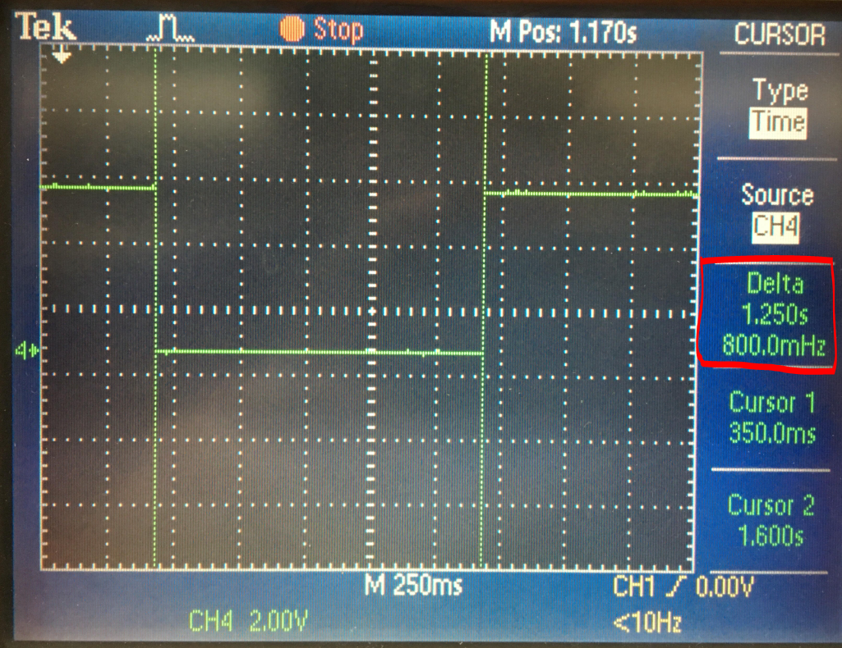

**TASK 2 Assembly SCOPE OUTPUT**

* **The Assembly code for part 2 yielded a small error of 50 ms. The oscilloscope shows 1.200 seconds between cursors, while our expected value was 1.250s. As was mentioned previously, this error is caused by the small overshoot for the time taken to complete the delay_1ms subroutine.**

**Width of Pulse is 1.200 seconds. Board Setup with PB2 and GND Connected to Probe**

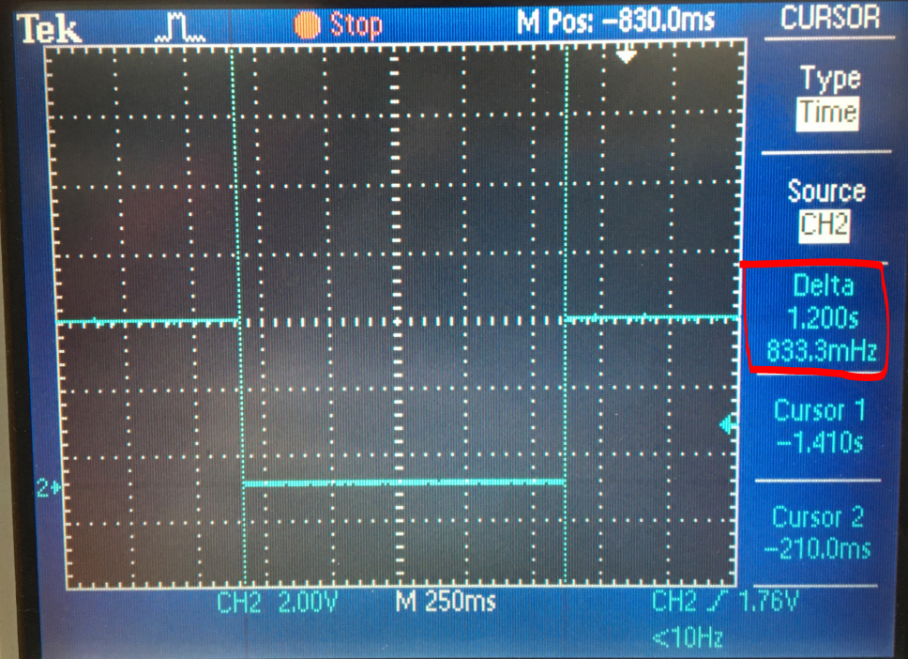

1. **VIDEO LINKS OF EACH DEMO**

**Link to my youtube video library:**

[**https://www.youtube.com/channel/UC4DhXgCIBkllvnwG6NH4sDA?view_as=subscriber**](https://www.youtube.com/channel/UC4DhXgCIBkllvnwG6NH4sDA?view_as=subscriber)

**TASK 1 C Code:** [**https://www.youtube.com/watch?v=yClkI5S3_iQ&t=18s**](https://www.youtube.com/watch?v=yClkI5S3_iQ&t=18s)

**TASK 2 C Code:** [**https://www.youtube.com/watch?v=EpZwVWvA-EU**](https://www.youtube.com/watch?v=EpZwVWvA-EU)

**TASK 1 Assembly:** [**https://www.youtube.com/watch?v=-tadpfDRS0s&t=3s**](https://www.youtube.com/watch?v=-tadpfDRS0s&t=3s)

**TASK 2 Assembly:** [**https://www.youtube.com/watch?v=ORVSoxsDOTU**](https://www.youtube.com/watch?v=ORVSoxsDOTU)

1. **GITHUB LINK OF THIS DA**

<https://github.com/skellj1/submission_da>

**Student Academic Misconduct Policy**

<http://studentconduct.unlv.edu/misconduct/policy.html>

“This assignment submission is my own, original work”.

James W. Skelly